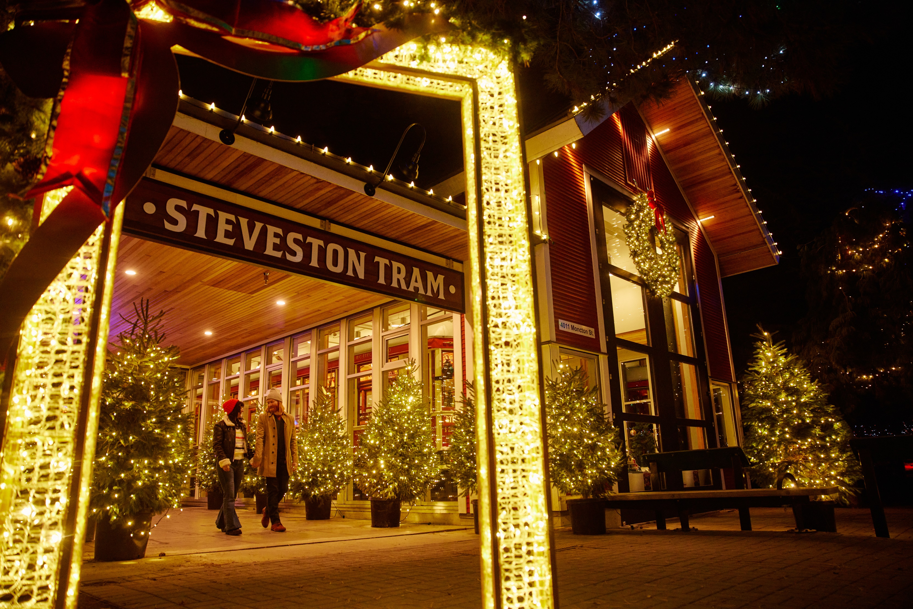
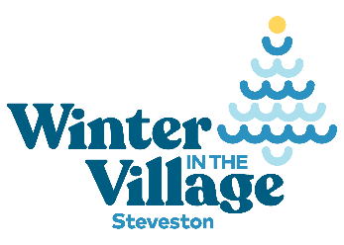

Winter in the village 2025 -
Experience sponsorship
Guidelines and Application

Winter in the village experience Sponsorship
introducing Winter in the village
The background
In 2019, Tourism Richmond and partners collaborated to create a tourism plan for Steveston. Our vision is to make Steveston BC's top coastal heritage experience. The plan has four main goals:
- Increase visitation and spending year-round to support business viability.
- Attract more visitors who are staying in Richmond and Metro Vancouver.
- Manage the growth of tourism in Steveston in a responsible way that contributes to the quality of life for the people who live, work and play in the village.
- Work with our community to create more reasons to visit Steveston by leveraging seasonal festivals, events, and experiences.
One strategy in the plan is to create new experiences to attract visitors during the shoulder and off seasons.
The Steveston Village community has always embraced the holidays with groups, societies, and businesses hosting many events and festivities happening over the season. In recent years to help with the promotion of these fantastic events Tourism Richmond partnered with the City of Richmond, Steveston Merchants Association, and other partners to bring all these festivities under one umbrella and brand called Winter in the Village. This approach allowed for a unified marketing message, efficient use of marketing funds, and the creation of a dedicated webpage listing information for all the events.
Winter in the Village is a key event identified in the Steveston Tourism Plan to boost December visitation and support year-round business viability. To guide Winter in the Village’s growth, specific goals and a vision have been established:
Goals:
- Provide activities for the community and visitors to enjoy during the holiday season.
- Increase visitation to Steveston Village to support local business.
Vision:
Winter in the Village is: A comprehensive and inclusive calendar of events and activities that engages the community and encourages participation from locals and visitors.

How do we achieve our goals and vision?
To achieve our goals and vision, we need a comprehensive calendar of events and activities throughout Late November and December. This should include a core layer of ongoing activities, complemented by a secondary layer of special events, programming, and weekend or evening offerings.
We already have a good number of events happening, however, to keep Winter in the Village evolving, it's crucial to add new events and programming each year. This will attract repeat visitors and ignite excitement among residents for new experiences to enjoy with their family and friends.
Now is the time to add new events to the calendar and (if necessary) enhance the popular events our community already love. Let's aim for an impressive WOW factor! We want Richmond residents to take pride in our village's festivities and enthusiastically invite their friends and family to join them during the holiday season. Visitors should feel a strong desire to come to our village and immerse themselves in the joy of the festivities!
Here are some examples of core and secondary special events, programming, and things to do:
Always on events:
- Holiday lights
- Holiday light display contest
- Festival of Trees

Special events and programming:
- Christmas Craft Market
- Songs in the snow
- Horse and carriage rides
- Santa comes to the village

Assistance with funding
Of course, adding events and things to do costs money and time. This is where the Experience Sponsorship comes in. Tourism Richmond has funds available to sponsor new or enhance existing special events, programming, and things to do. If there is something you, your business, or society has always wanted to do, yet have not had the funding available then now is your chance to receive funding for that idea!

Guidelines
The sponsorship funding is for use towards the costs for new Winter in the Village experiences, programming, activations, and events, or for the enhancement of existing Winter in the Village experiences, programming, activations, and events.
Sponsorship will be given to those applications that align with the goals and vision of Winter in the Village.
The application deadline is October 31, 2025

Eligibility

- Funding is available to any association, society, business, or entrepreneur who is hosting a relevant event/program/activity/experience from late November to 31st December 2025. All activity must happen in Steveston and occur exclusively in late November or December.
- Events can be on a single day, multiple days, regular days (e.g., Saturdays and Sundays), or always-on throughout the month.
- Events can be free or ticketed and must be open to the public.
- The initiative must encourage visitation to Steveston.
- Applicants must provide a marketing plan, targets, and provide details of the steps that will be taken to ensure success.
- Applications will score highly if they evidence how the initiative will drive incremental revenue for partners and encourage repeat visitation.
- Contingency plans must be considered to account for external factors such as bad weather.
- Collaboration with other Steveston businesses is strongly encouraged.

Eligible expenses include:
- Event planning costs
- Professional event planning and management assistance
- Printing of physical materials
- Equipment/furniture rentals
- Venue rental costs
- Marketing of the initiative
- Food and beverages related to hosting the event. E.g. hot chocolate
- Event related giveaways and raffle items

Ineligible expenses:
- Staff wages and rent
- Food and drink for staff/ volunteer subsistence
- Licenses, legal costs and insurance
- Building and infrastructure upgrades

terms, and conditions
- Applications will be accepted until October 31,2025.
- All expenditures must take place by December 31, 2025. Any expenses that occur from January 1, 2026, will not be reimbursed.
- The amount of funding available for each initiative will be at the discretion of Tourism Richmond, and could either be for the full amount or a percentage of the support requested.
- Payment of funds will be provided after the expense occurs. In special circumstances, Tourism Richmond may be able to provide funding sooner.
- The applicant is required to submit a Completion Form and submit receipts of payment for all expenses incurred. The Completion form and supporting documents must be submitted before January 5, 2026.

Application, Approval and Payment Process
- The applicant will fill out and submit this application form to coopmarketing@tourismrichmond.com
- Tourism Richmond will evaluate the application, and you will be notified via email if it is approved or denied within 10 days. If approved, the amount of funding will be confirmed at this stage.
- After the event has taken place, the applicant will submit a project completion form along with proof of expenditure.
- Tourism Richmond will evaluate and process the payment to the applicant.

application form

Contact name:
Company name:
Address:
Contact phone number:
Contact email:
Date of application:
Are you a stakeholder of Tourism Richmond: ☐Yes ☐No ☐Don’t know

Details of your special event, program, or activity:
Include here a detailed explanation of your new idea, or how you will enhance an existing event/program/activity/experience.
Event Date(s):

Description of event, including steps you will take to ensure the initiative is a success:

Please provide a marketing plan setting out the keyways you will promote your initiative:

Please identify the key risks and mitigations in delivering your initiative (e.g. bad weather, food preparation):

Targets (e.g. attendee numbers, promotion reach, incremental revenue):

How will your initiative encourage visitation to Steveston:

How will your initiative drive incremental revenue for your business, partners and Steveston village?

How will you use your event to encourage revisitation? E.g. promote future initiatives or annual passes:

Will you charge an admission fee?

Funding details – other than the sponsorship funding how else will you fund your event/program/activity/experience?

How much sponsorship funding would you like to receive?
$
Please also fill out schedule A (Excel Document) with your estimated budget breakdown.

By submitting this application to Tourism Richmond, we the undersigned,

- declare that we understand the eligibility criteria and program audit requirements.

- acknowledge that any approval of a Tourism Richmond funding is based upon our acceptance of the Winter in the Village Experience Funding Sponsorship Guidelines.

- acknowledge that Tourism Richmond reserves the right to amend or rescind its approved investment if the project is not completed, the evaluation report is not submitted or lacks sufficient detail, or the program was materially different than represented in this application.

- agree to notify Tourism Richmond in writing for further approval if there are changes to the expenses included in this application.

Signature ______________________________________

Print Name Click or tap here to enter text. Date: Click or tap to enter a date.

