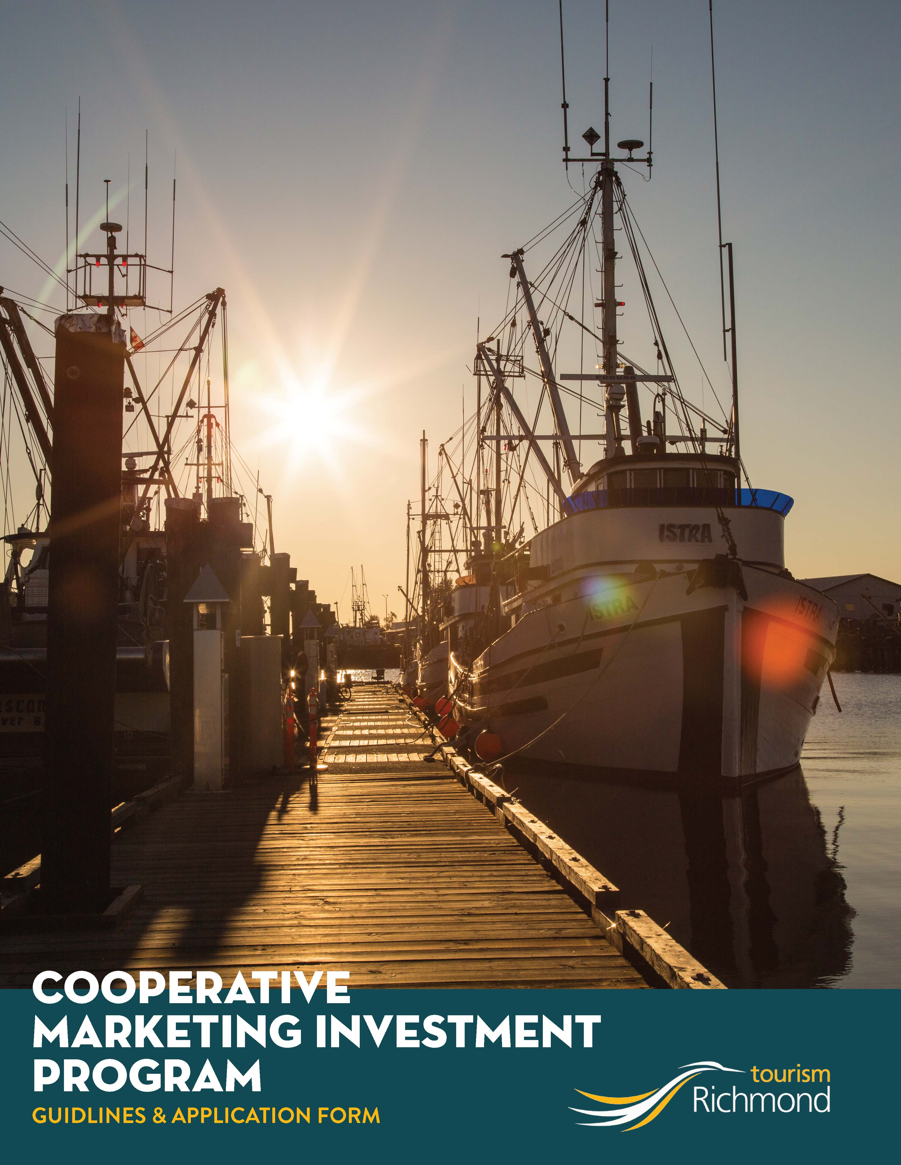
COOPERATIVE MARKETING
INVESTMENT PROGRAM

The Cooperative Marketing Investment Program supports the growth of Richmond’s tourism industry by investing in industry-led marketing initiatives to increase their marketing capacity, resulting in increased tourism revenues. The program provides funding for up to 50% of your marketing or experience development budget*.
You may apply under 2 main categories:
Marketing: Under the marketing category you can apply for funding towards a marketing campaign targeting visitors. The campaign must be trackable (digital preferable however we will consider traditional) and align with Tourism Richmond’s strategic plan and target market (British Columbia, Alberta, Washington State). Examples of Marketing initiatives:
- Integrated marketing campaigns
- Social and digital marketing campaigns
- Consumer show attendance
- Media and PR activities
- Photography and Video
- Written Content
Consider partnering with other tourism businesses to develop a more appealing tourism product to market. Examples of tactics include:
- Family Stay and Play Package (Hotel, Tour of the Cannery, Complimentary Breakfast)
- Shop and stay (Hotel and shopping gift card)
- Steveston Shopping Campaign

Experience Development: Investing in the development of new or enhanced tourism-related experiences supports the growth of Richmond’s tourism product offering, making our city a more desirable place to visit. Experience development initiatives should enhance the visitor experience in Richmond and align with Tourism Richmond’s strategic plan and be offered for a minimum of 3 years.
Funding can be put towards costs associated with the development or enhancement of new experiences including:
- Creative program development
- Translation costs and implementation to enhance visitor experience

Examples of experience development initiatives include:
- French Language Audio for tours
- Brochures announcing special events
- Photoshoots for image library

Eligibility
Richmond-based tourism-primary businesses or associations are eligible to apply for funding to develop compelling assets that support marketing initiatives. This initiative should help drive visitation to Richmond from outside the local area.

Timing
Initiatives must be fully completed December 31, 2022, to be eligible for 2022 funding. Initiatives that have already taken place are not eligible.

2022 Application deadline
Tourism Richmond will accept applications for 2022 until October 11, 2022, or until the funding pool has been exhausted. Applications must be submitted a minimum of one month prior to start date of any marketing activities.

All initiatives must end by December 31, 2022, to be eligible for 2022 funding. Funding will be awarded on a case-by-case, first-come-first-served basis. When all funds have been allocated, no further applications will be accepted.

Investment
Initiatives may qualify for up to 50 per cent investment from Tourism Richmond, up to a reasonable maximum, based on the initiative and organization for a maximum of three years. An additional three years of investment (at a reduced leverage for each additional year) may be available if steady and considerable revenue growth has occurred in the first three years.

Eligible and ineligible expenses

Eligible Expenses | Ineligible Expenses
INTERPRETIVE PROGRAM DEVELOPMENT FOR EXPERIENCE DEVELOMENT
Creative program development, commentary or scripting and storytelling development, expenses for a qualified contractor to assist with the development of the experience content; asset type such as audio headsets for translation. | Salaries or wages for employees – excluding contractors.
TRANSLATION RELATED FOR THE NEW EXPERIENCE OR TRANSLATION FOR THE EXISTING EXPERIENCE
Translation costs for the verbal or printed information that guide provides; safety information, waiver forms and other assets. | Translation to languages that are not aligned with Tourism Richmond’s business strategy.
BROCHURE AND FLAT SHEET DESIGN
Design and development of a brochure or flat sheet that articulates and provides sales support of the new experience; printing brochures. | Brochure distribution.
ONLINE/DIGITAL/SOCIAL MEDIA
Search engine optimization (SEO), display, email, social media, and mobile advertising; the hiring of an agency to develop, implement and manage your digital purchases and social media community will be considered on a need of the organization. | Targeted online ads in Richmond (exceptions may apply), project management fees, mobile apps (exceptions may apply).
PHOTOGRAPHY AND VIDEO
Experience-based photography and/or video that will be used for the marketing campaign or to promote the new experience. | Software, video production equipment, license fees.
WRITTEN CONTENT
Copywriting for marketing campaign, content marketing or description of experience/s for use in marketing materials | Software.
CONSUMER SHOW ATTENDANCE
Booth registration fees, additional passes if required, and accommodation. | Travel expenses including air, ground, meals and travel incidentals; prizing, incentives and promotional items; the marketing of a consumer or tradeshow.

Additional requirements
- Applicant must include a business and marketing plan for the new experience or marketing initiative in their application.
- For new experiences the applicant must provide a detailed proposal outlining their new experience. The proposal must include a detailed description of experience, price, time of year experience is available, markets the experience will cater to and supporting material required.
- Initiative supported must include the ‘In Partnership with Tourism Richmond’ logo where possible on marketing materials and webpages.
- Tourism organization/partners must have an active and updated profile/listing on Tourism Richmond’s website.

Program restrictions and payment details
- Tourism Richmond may invest up to 50% of the actual cost of the initiative. For example, if an initiative costs $30,000, the payment agreed upon is $15,000. If the incentive ends up costing greater than $30,000, Tourism Richmond will still only pay $15,000 towards the initiative. If the initiative comes in below budget, Tourism Richmond will only pay 50% of the lower amount.
- No retroactive funding is permitted for costs that have incurred prior to the application approval.
- After the project is complete receipts must be provided to Tourism Richmond and funding will be paid out. Tourism Richmond will not pre-pay for goods or services. All activities must have occurred and been paid for prior to the submission of an invoice for reimbursement.
- Capital type expenditures and operating costs are not eligible.
- Salaries or wages as well as management fees are not eligible.
- GST/PST expenses are not eligible.
- In-kind contributions are not eligible.

Reporting
All initiatives supported by Tourism Richmond must be evaluated and verified within 45 days (about 1 and a half months) of the project completion. A project is considered complete when the marketing tactics have ended, related expenses have been paid and objectives can be measured.

Tourism Richmond will supply the applicant with an evaluation form to complete. Copies of supporting documents, invoices, proof of payment etc. must be provided with the completed evaluation form to verify expenses.

Partners must supply Tourism Richmond with various statistical data, customer data and booking patterns for up to three years after the start of the initiative, this will be used for research purposes.

Application submission
We recommend contacting Tourism Richmond’s Destination and Industry Development Team prior to submitting your application to discuss your concept. At this stage, the Team Member will discuss ideas and review the investment criteria. After discussing the project, a written application is required. Once the application is submitted, it will be reviewed, and Tourism Richmond will provide written confirmation of its level of investment.

Application forms are available online at https://www.visitrichmondbc.com/stakeholder-funding-opportunities/ and should be emailed to coopmarketing@tourismrichmond.com

Application Form
Please do not submit hand-written applications as they are often difficult to read and will delay the process. Please complete in this user-friendly Word Doc and send the complete application (Word Doc & Excel Doc) by email.
Submission date: Click or tap to enter a date.
Please allow sufficient time (a minimum of one month) between the date of submission and the date the initiative activities will begin in order for the application to be reviewed and any necessary changes to be made.
Which Category will you be applying for?:
☐ Marketing Partnership
☐ Experience Development

1. Project Name: | Click or tap here to enter text.

. a) Name of Company Applying for Funding):
Contact Name: | Click or tap here to enter text.
Company: | Click or tap here to enter text.
Address: | Click or tap here to enter text.
City, Postal Code: | Click or tap here to enter text.
Phone No.: | Click or tap here to enter text.
Email: | Click or tap here to enter text.

Would you like to receive Tourism Richmond Industry E-newsletters? ☐ Yes ☐ No
Are you a not-for-profit organization? ☐ Yes ☐ No

b) Project Manager (if different than above):
Contact Name: | Click or tap here to enter text.
Company: | Click or tap here to enter text.
Phone No.: | Click or tap here to enter text.
Email: | Click or tap here to enter text.

3. Dates of inititive Expenses:
Start Date: | Click or tap to enter a date. |  | End Date: | Click or tap to enter a date.
Please provide a complete financial reconciliation (including an Evaluation form and financial backup for pertaining costs) to Tourism Richmond (by email or mail) within 45 days of the end date of the marketing expenses.

4. Identify The Target Market(s):
What are your target markets?:

If more than one market selected, please estimate the % of budget allocated to each region:
 | % | Metro Vancouver |  | % | Washington
 | % | British Columbia |  | % | Other State ( )
 | % | Alberta |  | % | Other International
 | % | Other Province ( ) |  |  | ( )
 | % | All Canada

Indicate which specific cities you are targeting, please estimate % of provincial or State budget:
 | % | Victoria |  | % | Other ( )
 | % | Seattle |  | % | Other ( )
 | % | Calgary |  | % | Other ( )
 | % | Other ( ) |  | % | Other ( )

5. Identify The Season The Campaign Is Targeting:
If more than one season is selected, please estimate the % of budget allocated to each season:
 | % | Winter |  |  | % | Spring |  |  | % | Summer |  |  | % | Fall

6. Description
Please provide an overview of the initiative (Marketing/Experience Development)

If more space is needed, please attach a separate page for more information

7. Marketing objective and performance measures (expected return on investment):
Examples of possible performance measures include: attendance, impressions, views, clicks, referrals, sales, etc.
When completing this section, include at least one objective that sets a target for increased revenue. For objectives that are providing a year over year increase, please indicate the previous year’s benchmark (i.e.: To increase sales by xx 2022, up from xxx in 2021).

What target/goal are you hoping to achieve? | What date will results be available?
Click or tap here to enter text. | Click or tap here to enter text.
Click or tap here to enter text. | Click or tap here to enter text.
Click or tap here to enter text. | Click or tap here to enter text.
Click or tap here to enter text. | Click or tap here to enter text.

8. ESTIMATED PROJECT BUDGET:
Now fill out Schedule A – Estimated Project Budget and Partner Contribution Excel Spreadsheet. On sheet one of this spreadsheet record all estimated expenses for your project, excluding GST. Tourism Richmond will allocate funding based on this budget, if expenses or vendors change during the project period inform Tourism Richmond as soon as possible because this will affect your funding application.

9. partner revenue (If Applicable):
Now fill out Schedule A – Estimated Project Budget and Partner Contribution Excel Spreadsheet. On sheet two of this spreadsheet outline how much each partner is estimated to contribute towards the initiative.

10. Partner Contact information (If Applicable):
Please provide information bellow if your application is on behalf of a partnership.
Company Name | Contact Person | Phone Number | E-mail Address
Click or tap here to enter text. | Click or tap here to enter text. | Click or tap here to enter text. | Click or tap here to enter text.
Click or tap here to enter text. | Click or tap here to enter text. | Click or tap here to enter text. | Click or tap here to enter text.
Click or tap here to enter text. | Click or tap here to enter text. | Click or tap here to enter text. | Click or tap here to enter text.
Click or tap here to enter text. | Click or tap here to enter text. | Click or tap here to enter text. | Click or tap here to enter text.

By submitting this application to Tourism Richmond we the undersigned,

- declare that we understand the eligibility criteria and program audit requirements.

- acknowledge that any approval of a Tourism Richmond investment into a marketing project is based upon our acceptance of the Cooperative Marketing Funds Guidelines;

- acknowledge that Tourism Richmond reserves the right to amend or rescind its approved investment if the project is not completed, the evaluation report is not submitted or lacks sufficient detail or the program was materially different than represented in this application.

- agree to notify Tourism Richmond in writing for further approval if there are changes to the program or if additional expenses are incurred that were not included in this application.

Project Manager:Click or tap here to enter text. Signature:

Please send completed forms to coopmarketing@tourismrichmond.com

For more information, please call 604.821.5473

